**Terraform Cloud**

Please make sure, you have done registration with <https://app.terraform.io/signup/account>

**Quick Steps to Create Account on Terraform Cloud**

1. Sign up with your email ID
2. 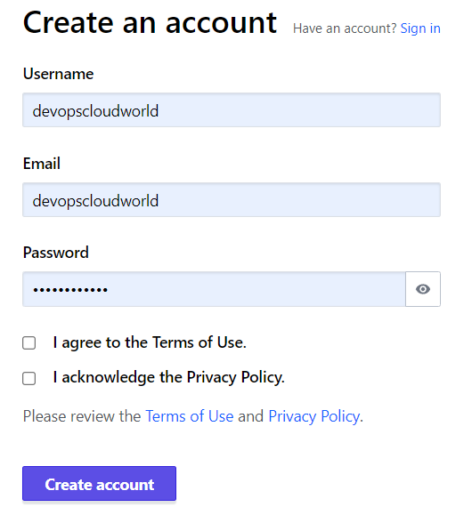
3. Create organization as mentioned below. Organization name can be anything.

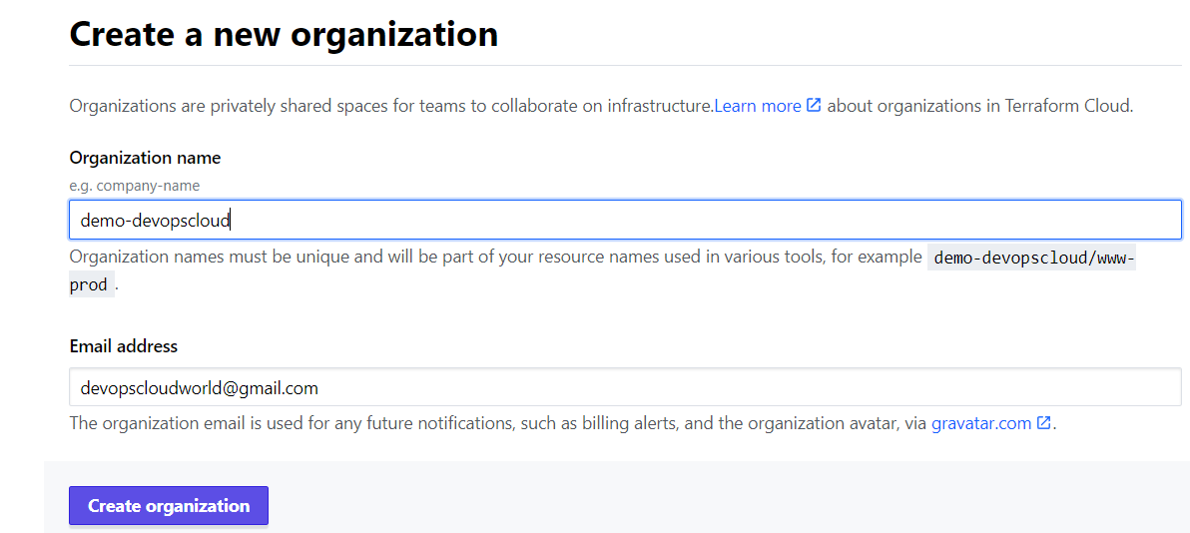

**Terraform Cloud – Configuring VCS Provider**

1. Go to settings -> Providers -> VCS Provider -> Add VCS Provider

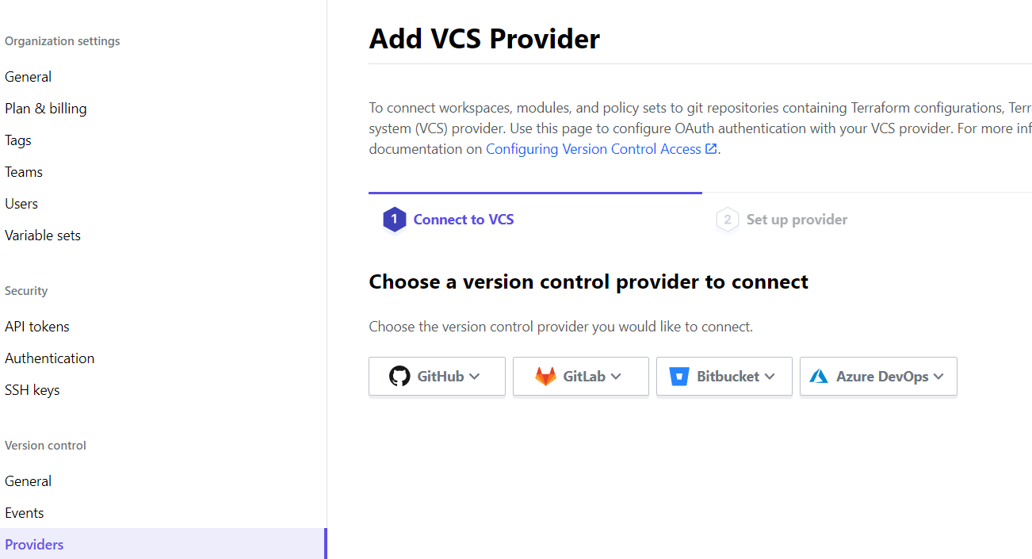

1. Click on link – register a new OAuth Application

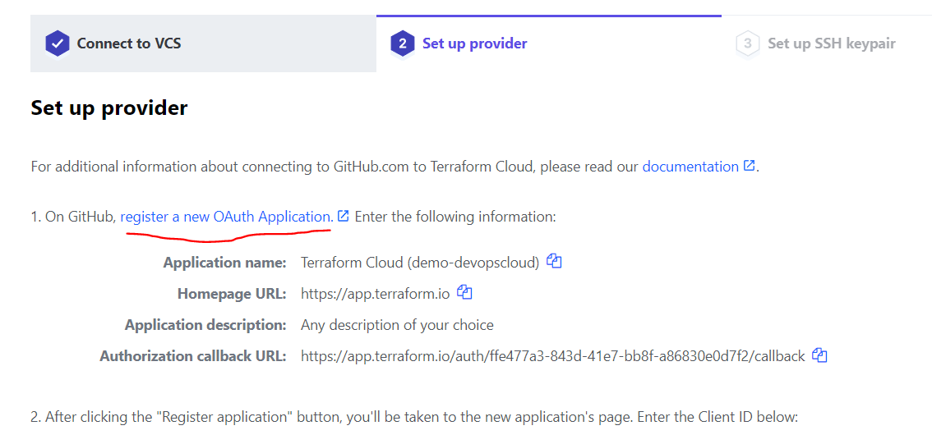

1. Login with your Github credentials and fill up the details from step 2

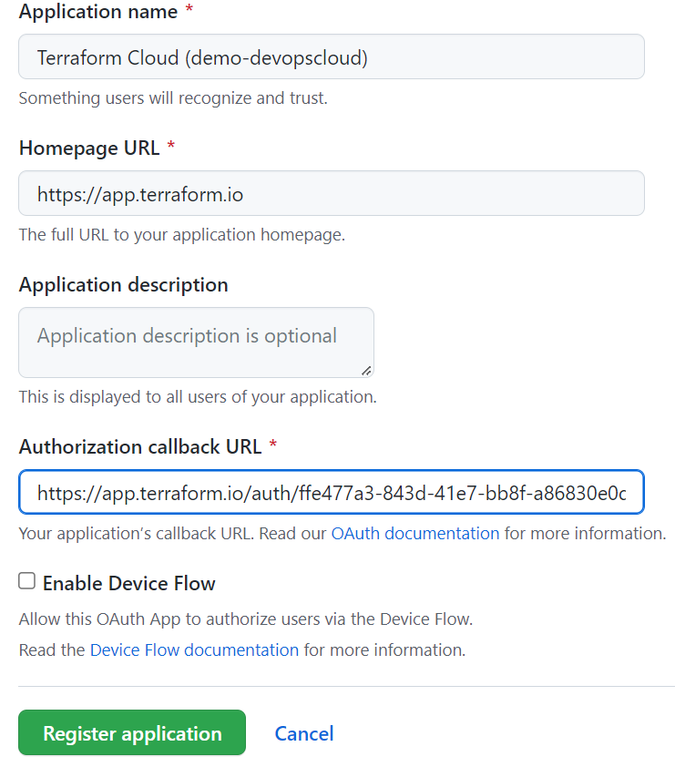

1. Clicking upon Register application, you will see client ID on next page as below, copy the same

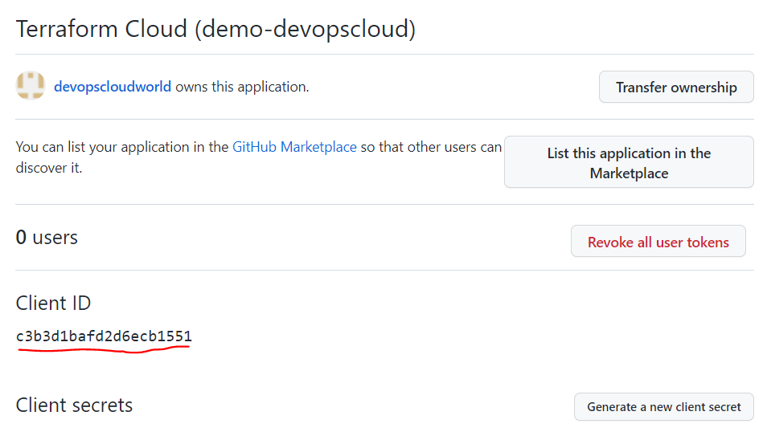

1. Enter above client ID on Terraform Cloud Page in step 2 as mentioned below

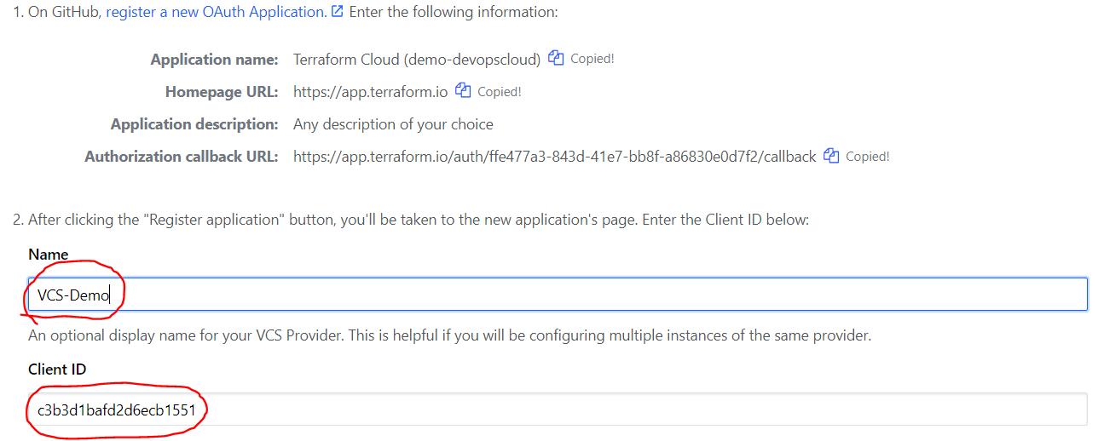

1. On Github page, generate a new client secret and copy that

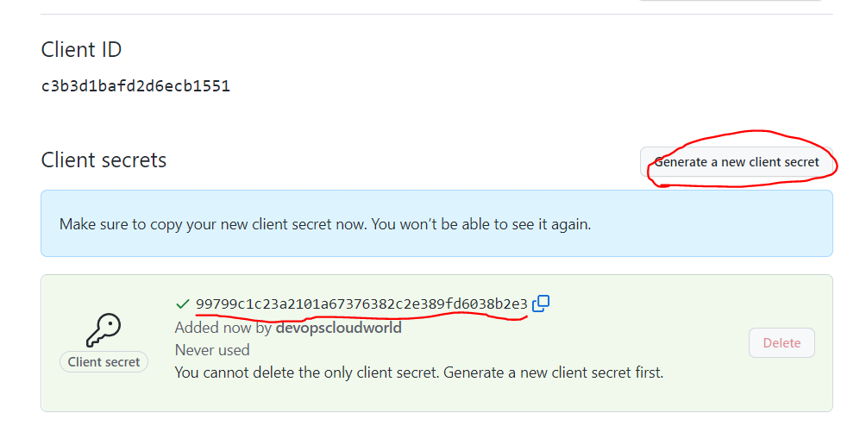

1. Enter above copied client secret in terraform configuration page as below, click connect and continue

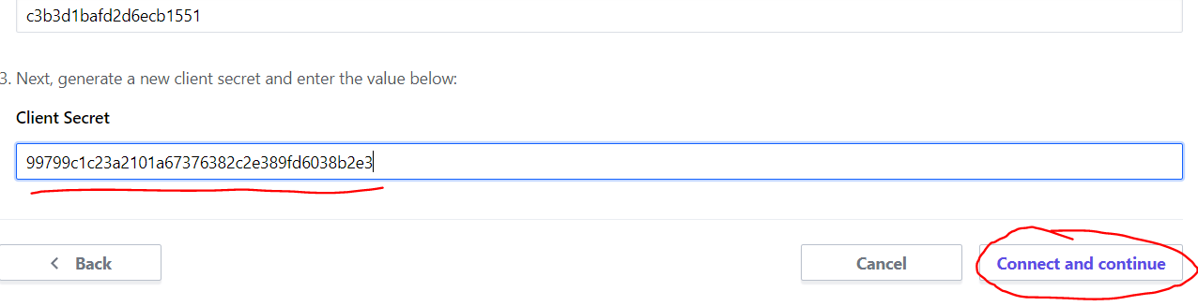

1. Click on Authorize. Setup SSH is optional and not required -> Click on Skip and finish

